Introduction
.....................................................................................................................................................................................................
welcome to our Company  Established in 1990, Sarvalakshmi Foundries has been the best integrated private sector company. SLF has been the Highest quality: Lowest cost Ferrous products manufacturers in India, and also been the prime suppliers of ferrous components for all major sectors. Sarvalakshmi Foundries has set the pace for the consolidation and globalization of the world grey-iron industry. We have spread best practice and modern production techniques throughout our plant. Our 500 strong customer base, includes household names in the automotive, engineering and appliance sectors. |  |  |  |  |  |  |  |  |  | 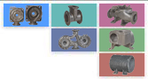
.................................................................................................................................................. |  |  |  |  |  |  |  |  |  | Facilities
Process & Quality |  |  |  |  |  | Production |  |  |  | » Melting  .....................................
» The Core Shop
.....................................
Since 30 years, Sarvalakshmi Foundries have manufactured Grey Iron Castings forcustomers with the highest quality requirements. An excellent product quality and a perfect customer service are the most important goals in our business.    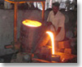 |  |  |  |  |  | Sarvalakshmi Foundries produces All grades of Grey and S.G iron castings to Indian and International standards.  can also be produced at a customer's request.  Twin Pump Casing  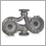  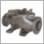  Bottom Casing
» Molding Center
.....................................
» Casting Finishing
.......................................
» Equipments
.....................................
» Pattern Facility
.....................................
.....................................................................................................................................................................................................
AboutUs
Sarvalakshmi Foundries was established in 1990 as a small scale industry. At that time, annual production was 350 tons of grey cast iron castings. 30 people worked in a single shift. Melting was carried out in a cupola. Hand-moulding was the major process of manufacture. The clients were mainly manufacturers of motors and pumps.
Today Sarvalakshmi Foundries has developed into a foundry with an annual capacity of 6000 tons of grey cast iron and s g iron castings. 125 people work in 3 shifts. Melting is done in a modern medium frequency 1.5 ton capacity coreless induction furnace. Moulding is carried out in Arpha 300,Arpha 450 and BQ5 moulding machines that are well-serviced by an automated sand-plant. Sand hoppers for storing 150 tons of moulding sand are available. This ensures that sand is adequately cooled before being recycled for moulding. High speed intemsive sand mixers supply sand of desired quality to the moulding machines. Adequate shot-blasting and fettling facilities are available in-house.
A well-equipped laboratory having modern process control equipments like spectrometer, universal testing machine, impact testing machine, Brinell hardness tester, microscope, sand-testing equipments, facilities for wet analysis etc are available.
The clients include manufacturers of automobiles, motors, pumps, compressors, textile machineries and other engineering industries. Sarvalakshmi Foundries have customers all over south India. Now they are aggressively planning to be world players. In order to achieve this, marketing offices have been opened in USA, Canada, France andAustralia.
.....................................................................................................................................................................................................
Our Philosophy
Sarvalakshmi Foundries growth has been founded on a consistent philosophy: that to be able to deliver the range and quality of products customers demand the modern Grey Iron maker. Sarvalakshmi Foundries enjoys access to world market through a sales and marketing network that touches every corner of the globe. A comprehensive portfolio of products allows SLF to deliver whatever our customers require – wherever they require it – and whenever they require it.
The management is progressive and forward-looking. A heavy investment has been made in modernizing and upgrading the foundry during the last two years. Competent and experienced personnel have been recruited in crucial areas. The company is fully committed to the idea that the customer is central to any business. Everyone in the foundry focuses on meeting and exceeding customer requirements – in terms of quality and timely supplies.
The management firmly believes in training and developing human resources. It is a matter of conviction that competent and committed employees are the best assets of an organization. Adequate in-house facilities are present for training and development of employees. They are also encouraged to attend professional seminars.
Today Sarvalakshmi foundries is an ISO 9001 certified organization with an efficient quality management system in place.
It is a matter of pride that Sarvalakshmi Foundries is one of the very few medium-size foundries in India that is ISO 14001 certified. Apart from meeting their business objectives, the management believes there are social obligations to be met in terms of nurturing a safe, non-polluting and healthy environment for the employees and society.
The foundry maintains plants and trees in and around the works. They have installed a rain-water harvesting unit within their works. High quality dust-collection systems including wet-scrubbers, bag filters and cyclone filters have been installed in the works
.....................................................................................................................................................................................................
Management
M r. P. Natarajan is the Founder of Sarvalakshmi Foundries (P) Ltd. He founded the company in 1989 and has been responsible for the strategic direction and development of its businesses. Mr. P. Natarajan’s ability to guide the company in its identification, and turnaround of grey-iron has led to its emergence as one of the India’s fastest growing ferrous component manufacturer.
Mr. P. Natarajan began his career working in the Cast-Iron making business in Coimbatore, India, and has over 30 years of experience working in Cast-Iron, paper, yarn and related industries. Mr. P. Natarajan is an active philanthropist and a member of various trusts. Lakshmi paper Cones is a significant contributor to local community and welfare activities. He has 2 sons, Prabhu Natarajan and Pradeep Natarajan.
Mr. Prabhu Natarajan is actively involved in issues of company, with a particular emphasis on administration, production and quality.
.....................................................................................................................................................................................................
Our Vision & Our Mission
Our Vision
To be among the global top 100 ferrous-iron component manufacturers.
Our Mission
Our mission is to be more than just successful. It is to be admired for our culture and for the quality, service and management standards that implies. Nothing less will do.
ISO 14001 - Environment
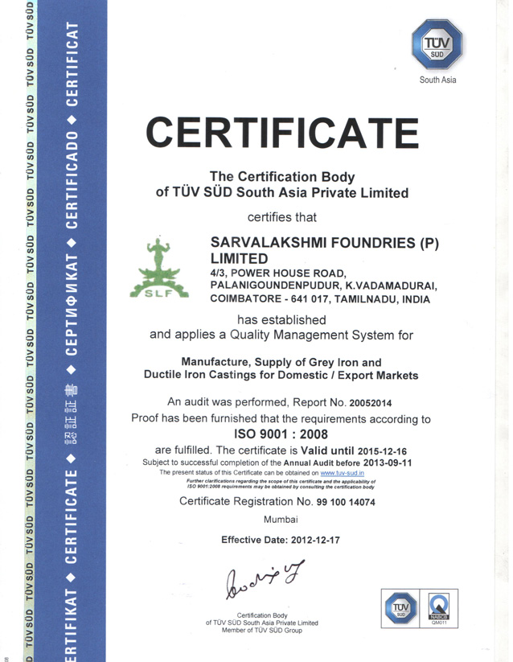
...................................................................................................................................................................................
Quality Certification For ISO 9001
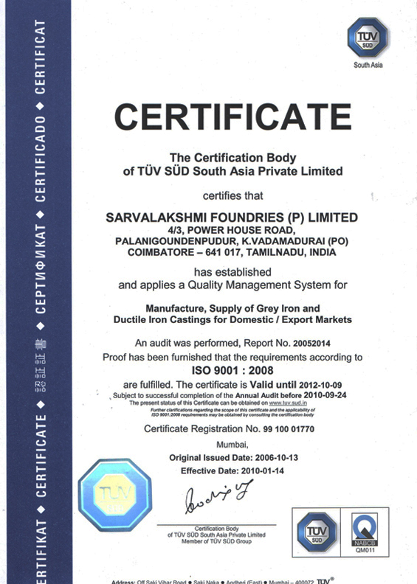
...................................................................................................................................................................................
Facilites
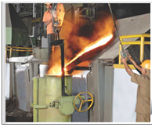 |  | A) Melting shop  Suitable materials are used to melt different grades of cast iron in the medium frequency core-less induction furnace. The chemistry of the molten metal is checked before pouring the castings. Pouring temperature and pouring speed of individual items are monitored to ensure consistently high quality of castings.
Induction furnace |  | 750 kW, Dual Track 1.5 ton capacity, medium frequency core-less induction furnace - Inductotherm make
Ladles |  | 250 kg capacity pouring ladles (5 nos)  500 kg capacity pouring ladles (2 nos)  1000 kg capacity ladles (2 nos)  2000 kg capacity ladle (1 no)
EOT crane |  | 5 ton capacity (1 no)
- Carbon equivalent meter for checking composition of molten metal before pouring
- Monorail system for mould pouring
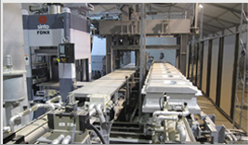
B) Moulding shop
The moulds are made of silica sand of high purity. The grain size and size distribution of this critical raw material is monitored during all supplies. Other moulding sand additives like bentonite and coal dust are also tested before use. The mixed sand that is supplied for making moulds is tested at regular intervals. The quality of moulds made is also routinely checked before they are closed and sent for pouring.
- Hand moulding to make up to 1000 kg single piece castings.
- Electric hoists to handle moulding boxes before & after moulding and also moulding bed during maintenance.
- Mould cars, track lines, pneumatic pushers.
- Green sand system in machine moulding.
- Green sand and CO2 silicate processes in hand moulding.
- CO2 silicate and no bake processes for cores
Moulding machines
  Moulding machines |  | moulding box size (mm)
  Horizontal High  Pressure Line |  | 850 × 600 × 300 ht
  (G.S)
  Horizontal High  Pressure Line Sinto |  | 500 × 400 × 180
Sand mixers |  |  | 500 kg capacity (2 no)  200 kg capacity (2 nos)
Sand plant |  |  | Including sand storage hoppers of capacity 120 tons, belt conveyors, bucket elevators, polygonal sieve, magnetic separators etc
EOT cranes |  |  | 5 ton capacity (1 no)  2 ton capacity (2 nos)
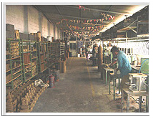 |  |  | C) Core-shop  Cores are made manually and by a core-shooter. Core-making is done by sodium silicate-CO2, amine and no-bake oil processes. The mixed sand used for making cores is tested regularly. Cores are inspected visually and for all critical dimensions before use. A sand drier is used to dry incoming wet sand during monsoon.
Sand drier |  |  | 1 ton / hr capacity (1 no)
Sand mixer |  |  | 100 kg capacity (2 nos)
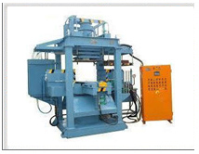 |  |  | Core-shooter  Cores manufactured by amine process (1 no)
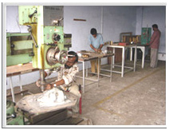 |  |  | D) Pattern shop  All patterns and core-boxes are inspected and corrected if required, before being released for production of moulds and cores. New patterns and core-boxes are checked for dimensions and methoding. Repairing facilities for wooden, aluminium, gun-metal and cast iron patterns and core-boxes are available in-house.  Continuous improvement in the areas of casting yield and cost reduction are carried out regularly.  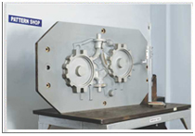  - Facilities for inspection, repair and mounting of patterns on match plates.  - Marking table for dimensional inspection of patterns, core boxes and castings.  - Methoding, mounting patterns and fixing gating & risering on match plates.
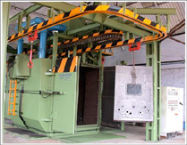 |  |  | E) Shot-blasting & fettling shop  The castings produced are cleaned of sand sticking. The running and risering systems are removed from the castings. They are then ground, finished, painted, packed (wherever necessary) and made ready for shipping.  Shot-blasting machine  Pedestal grinders  Portable electric and pneumatic grinding machines  Portable cut-off machines
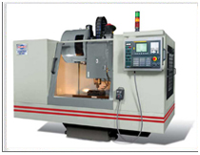 |  |  | Machining Facilities  - CNC Vertical Machining Centres  - Boring machines  - Milling machines  - Radial drilling machine’s  - Lathes  - Multi Spindle drilling and tapping machine  - Slotting machine  - Hydraulic testing rig.
F) Engineering services
Preventive maintenance of all equipments directly or indirectly involved in production is carried out. On the rare occasion of a machine breakdown, repairs are carried out. Spare-parts of critical machines are kept. The aim is to achieve zero breakdown in the long-term.
Department-wise energy consumption is also monitored and analysed. Suggestions for energy savings are implemented.
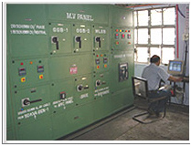
Power transformer |  |  | 22 kV / 575 V 850 kVA transformer for furnace  22 kV / 440 V 400 kVA transformer for auxiliary equipments
Compressors |  |  | Air-compressor screw-type; 8 kg/cm 2 pressure  Air-compressor screw-type; 8 kg/cm 2 pressure
Diesel Generators |  |  | 300 kVA capacity (1 no)  62.5 kVA capacity (1 no)
Furnace accessories |  |  | heat-exchangers, cooling water pumps, hydraulic power pack etc
Pollution control |  |  | Wet scrubbers, bag-type dust collectors, cyclone filters
Rain-water harvesting
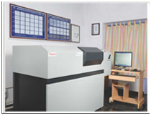  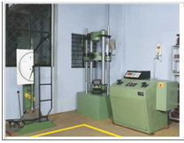  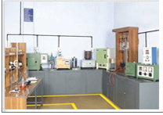 |  |  | G) Quality control & laboratory  - Spectrometer with provision to measure 22 elements to test Chemistry of incoming raw materials and molten metal before pouring castings.  - Sand testing equipments (permeability, compactability, moisture, green compression strength, green shear strength, AFS number, Active clay, Dead clay, Total clay, Ash, Loss on ignition, Volatile matter for testing incoming, moulding and core sands.  - Universal Testing Machine of 40 T capacity to test mechanical properties of various grades of metal being poured.  - Brinell and Poldi hardness testers to check hardness of castings, and critical bought-out items like moulding pins, closing pins, bushes etc  - Metallurgical microscope for microstructure analysis of metal poured in various heats.  - Impact testing machine (Charpy and Izod tests) to check impact toughness of metal poured.  - Wet analysis testing facilities.  - Facilities for dimensional inspection of castings, patterns and core boxes.
Spectrometer |  |  | 3460 model Spark emission spectrometer ARL - make
Carbon-equivalent meter |  |  | Rapid carbon and silicon testing in molten metal
Universal testing machine |  |  | 40 ton capacity
Impact testing machine |  |  | Izod test - 330 J capacity  Charpy test - 600 J capacity
Brinell hardness tester |  |  | 750 / 3000 kg loading capacity
Sand-testing equipments |  |  | Sieve shaker; Permeability meter; Mould-hardness tester; Total clay, active clay and dead clay tests; Fixed carbon, volatile matter and percentage ash tests; Green compression and shear strength tester; Moisture tester
...................................................................................................................................................................................
Product Overview
Gray & SG Iron Casting
Sarvalakshmi Foundries produces a wide range of grey cast iron and SG iron castings to Indian and equivalent international standards.
Production capacity |  |  |  | 6000 tons per annum
Current production |  |  |  | 3000 tons per annum
Capacity available |  |  |  | 3000 tons per annum
Casting weight |  |  |  | up to 100 kg in machine moulding  up to 1000 kg in hand-moulding
Moulding machines
  Moulding machines |  | moulding box size (mm)
  Horizontal High  Pressure Line |  | 850 × 600 × 300 ht
  (G.S)
  Horizontal High  Pressure Line Sinto |  | 500 × 400 × 180
Floor moulding |  |  |  | Adequate floor-space, skilled man-power, different sizes of moulding flasks and handling equipments available for making heavy castings weighing up to 1250 kg.
Moulding process |  |  |  | Green sand process; CO2-silicate process
Core-making process |  |  |  | CO2-silicate process; No-bake oil process; Amine process
Grades |  |  |  | Cast iron and SG iron castings conforming to Indian Standards are presently manufactured. Castings to any other international standard required by a customer can also be manufactured.
Casting types |  |  |  | Castings catering to a wide range of industrial segments are manufactured – valves, fittings, automobiles, pumps, motors, compressors, machineries and other engineering industries
Product Portfolio
Pump Casing  250kgs  Grey Iron |  |  |  | 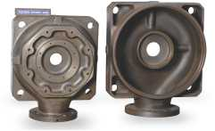
Valve Body  36kgs  SG Iron |  |  |  | 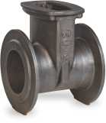
Twin Pump Casing  170kgs  SG Iron |  |  |  | 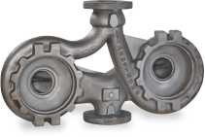
Bottom Casing  250kgs  Grey Iron |  |  |  | 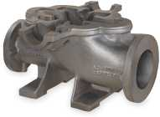
Gear Box Housing  35kgs  SG Iron |  |  |  | 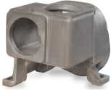
Motor Body  160kgs  Grey Iron |  |  |  | 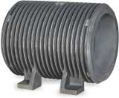
...................................................................................................................................................................................
Quality Policy
“Our Target is Your Success"
Since 30 years, Sarvalakshmi Foundries, have manufactured Grey Iron Castings for customers with the highest quality requirements. An excellent product quality and a perfect customer service are the most important goals in our business.
Sarvalakshmi’s Policy is to take a planned approach to continuous improvement of our products, processes and services to meet or exceed our customer's expectations 100% of the time.
To produce our castings, only the best raw material is acceptable. We are exclusively using the finest scrap, coal and chemicals from the world's preferred vendors and manufacturing companies. To make sure that every single piece meets our strict requirements; all finished part is tested and approved by our specialists before shipment.
Our process and workforce that delivers consistent product quality translates directly into increased productivity and lower costs.
...................................................................................................................................................................................
Green Environment
In tune with environmental friendly philosophy of the organization,
the following activities are also carried out.
- Planting and maintaining plants and trees.
- Rain water harvesting.
- Pollution control equipments installed and pollution tests carried out regularly for monitoring effectiveness.
- Reclaiming and recycling used sand.
- Residential quarters for staff and workers close to the organization.

Pollution Control
 |  |  |  |  | Sarvalakshmi Foundries has implemented pollution prevention/ control program.  What Is pollution prevention?  "An Act to improve, strengthen, and accelerate programs for the prevention and abatement of air pollution and all pollution"
Pollution prevention is the substantial reduction or elimination of discharges or emissions to the environment. This includes all pollution: hazardous and non-hazardous, regulated and unregulated, across all media, and from all sources. Pollution prevention can be accomplished by reducing the generation of wastes at their source (source reduction).
By reducing or eliminating wastes
• Reduce waste disposal costs
• Reduce costs for energy, water and raw materials
• Reduce operating costs
• Protect workers, the public and the environment
• Reduce risk of spills, accidents and emergencies
• Reduce vulnerability to lawsuits and improve its public image
• Generate income from wastes that can be sold.
How do we achieve this
• Improved Operating Procedures
• Materials Substitution
• Process Modifications & Redesign
• Treatment Alternatives
• Recycling
SLF demonstrates its commitment to pollution prevention and encourage employee
participation by:
• Training employees in pollution prevention techniques
• Encouraging employee suggestions
• Providing incentives for employee participation
• Providing resources necessary to get the job done
...................................................................................................................................................................................
Wind Energy

We are operating one Wind Electric Generator with installed capacity of 500 KW. This generator is capable to generating 50% of our total annual power requirements. Sarvalakshmi Foundaries has planned to install more wind electric generators for our power requirements.
...................................................................................................................................................................................
Rainwater Harvesting
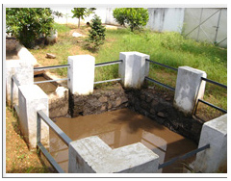 |  |  |  | A strong safety culture is instilled at every level of Sarvalakshmi Foundries. It is a fundamental tenet of Sarvalakshmi Foundries that safety must rank alongside issues of quality, productivity and profitability in the decision-making process. A safe workplace demonstrates a commitment to being a respected and admired organisation and fosters positive attitudes on the part of employees and other stakeholders. In short, a safe business is a good business.
A standardised approach is key. All business units must abide by the same high principles on health and safety, conduct the same core safety activities, undertake the same audit and achieve the same standard of excellent housekeeping.
An important element of safety policy is the sharing of experience throughout the company. They are then shared among all the company’s health and safety teams. We have a clear vision at Sarvalakshmi Foundries. It is to establish a safety record that puts us consistently among the top 10 percent of the Domestic grey-iron manufacturers and ensures every business unit matches the standards of the very best. We aim to surpass local regulatory requirements, not just meet them.
...................................................................................................................................................................................

Health and Safety
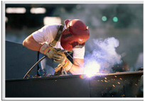 |  |  |  | Sarvalakshmi Foundries intends to protect the health and safety of everyone in the workplace, and ensure that adequate welfare facilities are provided for people at work. These regulations aim to ensure that workplaces meet the health, safety and welfare needs of all members of a workforce, including people with disabilities.
A strong safety culture is instilled at every level of Sarvalakshmi Foundries. It is supported by a robust set of safety standards and a system of performance monitoring. It is a fundamental tenet of Sarvalakshmi Foundries that safety must rank alongside issues of quality, productivity and profitability in the decision-making process. A safe workplace demonstrates a commitment to being a respected and admired organisation and fosters positive attitudes on the part of employees and other stakeholders.
In short, a safe business is a good business.
A standardised approach is key. All business units must abide by the same
high principles on health and safety, conduct the same core safety activities.
An important element of safety policy is the sharing of experience throughout
the company.
We aim to surpass local regulatory requirements, not just meet them.

Dust Collection
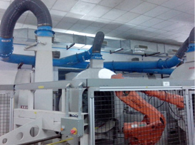 | State of the art dust collectors are installed which ensures an emission levels less than all National and International legislations  Sarvalakshmi Foundries is committed to rapid modernization and growth keeping in mind the universal focus on a clean and healthy environment. Modern manufacturing as well as pollution control equipments have been installed in the company. The pollution control equipments include wet scrubbers in the melting department, bag filters and cyclone dust collectors in the sand-plant and shot-blasting machine. Waste sand is used for land-filling.  The foundry is involved in other environmental management activities also. Plants and trees are grown and maintained in and around the works. A rain-water harvesting unit has been installed inside the works.
Strict control over the quality of incoming raw materials also helps to reduce their consumption. This reduces cost, material wastage and indirectly helps in pollution control.
An associate company has also installed a 500 KW capacity wind-mill to tap into non-conventional forms of energy in power generation.
Sarvalakshmi Foundries is one of the very few medium-size foundries in the country that is ISO 14001 certified. Apart from meeting their business objectives, the management firmly believes in nurturing a safe, non-polluting and healthy environment for the society.
...................................................................................................................................................................................
Technical Capabilities
Sarvalakshmi Foundries manufactures a wide range of grey cast iron and s g iron castings to Indian standards. Castings to other international standards can also be manufactured based on customer’s requirements.
Production capacity |  |  |  | 6000 tons per annum
Current production |  |  |  | 3000 tons per annum
Capacity available |  |  |  | 3000 tons per annum
Casting weigt |  |  |  | up to 100 kg in machine moulding  up to 1000 kg in hand-moulding
Casting types |  |  |  | Castings catering to a wide range of industrial segment saremanu factured valves, fittings, automobiles, pumps,motors, compressors,machineries and otherengineering industries
Process Flowchart
Pattern Shop | Patterns | Moulding Shop |  | Melting Shop
Core Boxes Moulds Molten Metal
Core Shop | Cores | Mould – Closing Bay
Closed Moulds
Pouring Bay
Pored Moulds
Knockout Section
Rough Casting
Shot Blasting Section
Cleaned Casting
Fettling Shop | Finished  Casting | Shipping Yard
Product Development Flowchart
Technical discussion
with customers

Studying drawing
& designing process

Pattern / Core – box
design

CNC tool path
Programing

Pattern & Core – box
manufacturing

Sample production

Pilot production

Bulk production

Sarvalakshmi Foundries has installed some of the latest equipments in quality control and process control areas. They help ensure that highest level of quality castings are poured each time consistently. Some of the instruments available for process control are:
3460 model AProcess Control RL spectrometer for rapid and accurate analysis of molten metal before pouring. This ensures that no off-grade metal is poured.
Carbon-equivalent meter for quick cross-check of carbon and silicon in molten metal before pouring. As carbon and silicon are two important elements that control cast iron characteristics, this built-in cross-check ensures a fail-proof system.
As an additional back-up a well-equipped laboratory with facilities for wet analysis of the casting chemical composition is also available
Test-bars are regularly poured and tested for mechanical properties like tensile strength, yield strength, elongation and impact strength. This ensures that customers’ requirements in terms of mechanical properties are met in all supplies.
Casting microstructures are checked frequently as a cross-check to ensure that all customers’ requirements, including ease of machinability, are met.
A well-equipped inspection department with surface table and instruments for dimensional check of castings are also available
With Sarvalakshmi Foundries the customer is assured of total quality and integrity of castings along with timely supplies.
Equipments & Machinery
(A) Melting shop
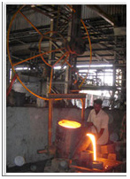 |  |  |  | Induction furnace |  |  | 750 kW, Dual track 1.5 ton capacity, medium frequency core - less  induction furnace - Inductotherm make
 |  |  |  | Ladles |  |  | 250 kg capacity pouring ladles  (5nos) 500 kg capacity pouring ladles (2 nos) 1000 kg capacity ladles(2nos) 2000 kg capacity ladle(1no)
 |  |  |  | EOT crane |  |  | 5 ton capacity (1 no)
B) Moulding shop
Moulding machines
  Moulding machines |  | moulding box size (mm)
  Horizontal High  Pressure Line |  | 850 × 600 × 300 ht
  (G.S)
  Horizontal High  Pressure Line Sinto |  | 500 × 400 × 180
Sand mixers |  |  |  | 500 kg capacity (2 no)  200 kg capacity (2 nos)
Sand plant |  |  |  | Including sand storage hoppers of capacity 120 tons,  belt conveyors, bucket elevators, polygonal sieve,  magneticseparators etc
EOT cranes |  |  |  | 5 ton capacity (1 no)  2 ton capacity (2 nos)
C) Core-shop
Sand drier |  |  |  | 1 ton / hr capacity (1 no)
Sand mixer |  |  |  | 100 kg capacity (2 nos)
Core-shooter
Cores manufactured by amine process (1 no)
D) Pattern shop
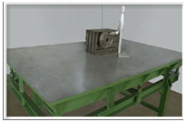 |  |  |  | Marking table |  |  | for dimensional inspection of patterns,core-boxes Castings(2nos)
 |  |  |  | Drilling machine |  |  | Radial drilling machine (1 no)  Ordinary drilling machine (1 no)
(E) Shot - blasting & fettling shop
 |  |  |  | Shot-blasting machine
 |  |  |  | Pedestal grinders
 |  |  |  | Portable electric and pneumatic grinding machines
 |  |  |  | Portable cut-off machines
F) Engineering services
Power transformer |  |  |  | 22 kV / 575 V 850 kVA transformer for furnace  22 kV / 440 V 400 kVA transformer for auxiliary equipments
Compressors |  |  |  | Air-compressor screw-type; 8 kg/cm 2 pressure  Air-compressor screw-type; 8 kg/cm 2 pressure
Diesel Generators |  |  |  | 300 kVA capacity (1 no)  62.5 kVA capacity (1 no)
Furnace accessories |  |  |  | heat-exchangers, cooling water pumps, hydraulic  power pack etc
Pollution control |  |  |  | Wet scrubbers, bag-type dust collectors, cyclone filters
Rain-water harvesting
G) Quality control & laboratory
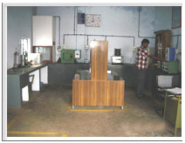 |  |  |  | Spectrometer |  |  |  | 3460 model Spark emission spectrometer ARL - make
 |  |  |  | Carbon- equivalent meter |  |  |  | Rapid carbon and silicon testing in molten metal
 |  |  |  | Universal testing machine |  |  |  | 40 ton capacity
 |  |  |  | Impact testing machine |  |  |  | Izod test - 330 J capacity  Charpy test - 600 J capacity
 |  |  |  | Brinellhardness tester |  |  |  | 750 / 3000 kg loading capacity
 |  |  |  | Sand-testing equipments |  |  |  | Sieveshaker;Permeability meter;  Mould- hardness tester;Total clay,activeclay and deadclay  tests;Fixedcarbon,volatile  matterand percentage ashtests;  Green compression and shear strength tester;Moisture tester
 |  |  |  | Wet analysis facility for chemistry of metal poured.
Metalurgical Capabilities
Grades : Cast iron and s g iron castings conforming to Indian Standards are presently manufactured.
Castings to any other international standard required by a customer can also be manufactured
Material | ASTM | BS | DIN | JIS | ISO | Percentage poured

 | A536 | 2789 | 1693 | G 5502 | 1083
 | 60-40-18 | 370 / 17 | GGG 40 | FCD 40 | 370 - 17
 | 65-45-12 | 400 / 12 | GGG 40.3 | FCD 45 | 400 - 12
 | 80-55-06 | 450 / 10 | GGG 50 | FCD 50 | 500 - 7
 | 80-60-03 | 500 / 7 | GGG 60 | FCD 60 | 600 - 3
 | 100-70-03 | 600 / 3 | GGG 70 | FCD 70 | 700 - 2
Grey Iron  Castings | A 48 | 1452 | 1691 | G 5501 | R 185 | 80 %
Grey Iron  Castings | Grade20 A | Grade 15 | GG 15 | FC 15 | Grade 15 | 80 %
Grey Iron  Castings | Grade25 A | Grade 20 | GG 20 | FC 20 | Grade 20 | 80 %
Grey Iron  Castings | Grade30 A |  | GG 25 | FC 25 | Grade 25 | 80 %
Grey Iron  Castings | Grade35 A |  | GG 30 | FC 30 | Grade 30 | 80 %
Gray Iron Grades | ASTM | Hardness Range | Minimum Tensile
SAE Grade G2500 J431 | A15 9 - 83 | 170 - 229 BHN  4.6 - 4.0 BID | 25,000
SAE Grade G2500 J431 | A159 - 83 | 187 - 241 BHN  4. 4 - 3.9 BID | 30,000
SAE Grade G2500 J431 | A159 - 83 | 207 - 255 BHN  4.2 - 3.8 BID | 35,000

SG Iron Grade
................................................................................................................................................................................

People
Loyal, competent and committed people are the most precious resource in any organization. Selection of personnel, their training, monitoring effectiveness of training methods, providing them opportunities for development and growth etc are all planned carefully and monitored scientifically. Employees are encouraged to attend professional seminars.
The staff in Sarvalakshmi Foundries are well qualified and experienced. They have the freedom and authority to run each individual department effectively.
Clean and well-illuminated dining rooms are provided for the staff and workmen.
................................................................................................................................................................................
Contact Us
SARVALAKSHMI FOUNDRIES (P) LIMITED
4 / 3, Power House Road,
Palanigoundenpudur,
K.Vadamadurai P.O, Coimbatore - 641 017.
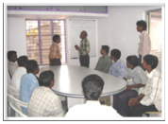
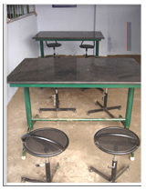
Office : 2642334, 2644928, Fax : 2642446.
E-mail : slf90@rediffmail.com

